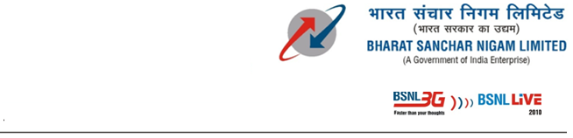
Information Technology Cell
lwpuk izkS|ksfudh lsy
O/o Chief General Manager
eq[; egkizca/kd dk dk;kZy;]
Tamilnadu Telecom Circle
rfeyukMq nwjlapkj ifjeaMy
Chennai / psUubZ – 600 002

l . / No. IT/C102 -10/SMS/2010-11/ 22 fnukad / dated at psUubZ / Chennai – 2 the 04-10-11
lsok esa / To
All the Head of SSAs/ Functional Units
fo’k;/Sub:- Sending of Bulk SMS through TN SMS package– Reg .

To comply with the TRAI’s new regulation our TNSMS is blocked by SMSC Madurai. If by chance SMS is wrongly sent to the Do Not Call numbers, penalty will be charged heavily. Certain modifications have to be done in the TNSMS package to comply with TRAI regulation TCCCP 2010.
For sending SMS through TNSMS packages, it is requested to follow the procedures given below :
- SMS should be sent to the BSNL service mobile numbers only.
- It is the responsibility of the user to ensure that no SMS is sent to the mobile numbers registered in Do Not Call register
- The sender names will be changed in the SMS package as BT – XXXXXX (BT – followed by 6 alpha characters) as per the TRAI regulation TCCCP 2010. And the details will be intimated to all concerned users. A copy of the sheet showing the mapping of old/new sender details is enclosed in Annexure.
It is the responsibility of the User of the Package to adhere strictly to the above said conditions to comply with the provisions of TCCCP Regulations and any failure in fulfilling the above conditions will attract heavy penalty. The UserId and password details may be kept confidential and any sub delegations of such details will be under the sole responsibility of the actual sms package user holding the SMS domain.
Sd

egkizca/kd (aa chih & vkbZ Vh ) / General Manager (BP & IT)

eq-e-iz- dk dk;kZy;] rfeyukMq ifjeaMy / O/o CGMT, TN Circle

Chennai -600 002 / psUubZ

